72% Organic Traffic Growth for a Maryland Law Firm

SEO

Results that speak for themselves

Key Stats & Results


72% Year-over-year organic traffic growth

93% Increase in contact form submissions

Behind the transformation

72% Organic Traffic Growth After Merging Two Law Firm Websites
A Maryland-based personal injury and criminal defense law firm partnered with Rankings.io to rebuild its organic search strategy after years of underperforming SEO efforts. By consolidating two competing websites into a single authoritative domain, eliminating widespread keyword cannibalization, and implementing a focused legal SEO strategy, the firm achieved 72% year-over-year organic traffic growth and a 93% increase in contact form submissions. The result was a stronger digital foundation that consistently generates high-intent cases across Maryland’s competitive legal market.

FROM CHALLANGES TO SUCCESS


The Challenge
When this Maryland-based personal injury and criminal defense firm partnered with Rankings.io, the challenge was both strategic and structural: A high-volume practice that depends entirely on new client acquisition every month had spent years cycling through SEO agencies and had nothing durable to show for it.
Unlike corporate law firms that retain long-standing clients, this firm operates on short case cycles of three months to a year. That makes a consistent, high-performing organic pipeline existential, not optional. Every month without strong search visibility is a month of missed cases.
The firm had tried paid search, but found the ROI unsustainable. The real need was a strong organic foundation—a well-optimized site with content that attracted the right clients and converted them at the right moment.
Between 2009 and 2016, the firm worked through four or five SEO providers. Each agency made the usual promises and failed to deliver, not because of effort, but because legal SEO requires specialized expertise that most generalist agencies simply lack.
By the time the firm engaged Rankings.io, it had two separate websites, one for criminal defense, one for personal injury, each requiring its own content pipeline, and together generating significant keyword cannibalization across approximately 1,700 pages.
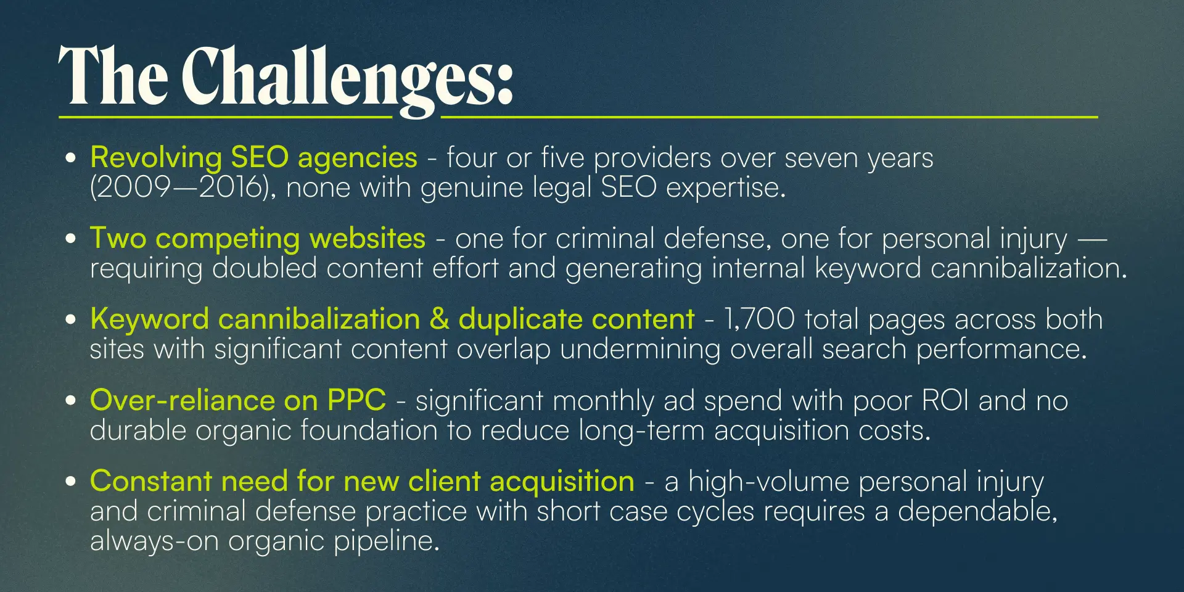



How We Did It: The Strategy
Rankings.io took full ownership of both websites, beginning with a comprehensive audit and optimization pass. But the defining strategic decision came later: merging two fully developed sites into a single, authoritative property.

SEO Strategy for a Maryland Personal Injury & Criminal Defense Firm
We built the strategy around consolidation, content authority, and clean architecture, eliminating the structural issues that suppressed rankings, then built a durable organic presence from a single, unified platform.

1. Complete Website Audit & Baseline Optimization
Rankings.io began with a thorough assessment of both existing websites, identifying what worked, what hurt rankings, and what the firm needed to rebuild. We addressed on-page optimization, site structure, and internal linking before we began any migration work.

2. Strategic Site Merge — Two Sites Into One
In November 2017, Rankings.io executed a full content consolidation and site merge, unifying the criminal defense and personal injury websites into a single domain. This eliminated the need to maintain two parallel content pipelines and allowed the firm's full link equity and topical authority to compound in one place.
The merge required reconciling the content and design systems of both sites, retargeting all content across both practice areas, and carefully managing 301 redirects to preserve link equity throughout the transition.

3. Keyword Cannibalization Elimination & Content Consolidation
With 1,700 pages spread across two sites, significant cannibalization suppressed rankings. Rankings.io audited every page, consolidating the architecture down to 720 high-quality, non-competing pages. We folded content from underperforming standalone pages into existing high-traffic pages, strengthening their authority rather than fragmenting it.

4. Maryland-Focused Permalink & Geographic Targeting
To ensure the newly merged site captured maximum Maryland market share, Rankings.io restructured the site's permalink architecture to better target Maryland-specific demographics and search intent — aligning URLs, page structure, and content with how local audiences actually search.

5. Link Building & .gov Outreach
To strengthen domain authority following the merge, Rankings.io implemented a targeted link-building campaign, including .gov outreach, earning high-authority government backlinks that contributed meaningfully to the site's credibility and ranking power in competitive local search results.



Before & After
Within one year, the firm had achieved measurable, compounding growth across every key organic performance metric.
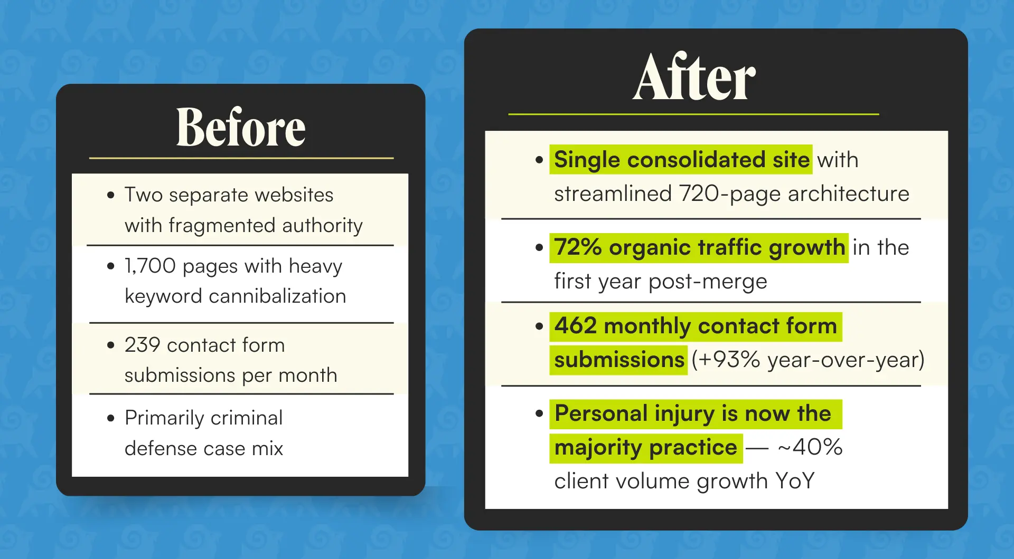
The firm's case mix shifted meaningfully post-merge: Personal injury, the higher-value practice area, grew to become the majority of inbound work, with client volume up approximately 40% year-over-year. We secured first-page rankings for the firm for competitive Maryland terms, including Baltimore car accident lawyer, Baltimore DUI lawyer, and Maryland DUI lawyer.

Key Wins
- 72% organic traffic growth in the first year following the site merge
- 93% increase in contact form submissions: 239 → 462 per month year-over-year
- Page count reduced from 1,700 to 720 — eliminating cannibalization and consolidating authority onto high-performing pages
- First-page rankings achieved for competitive terms, including Baltimore car accident lawyer, Baltimore DUI lawyer, and Maryland DUI lawyer
- ~40% year-over-year growth in personal injury clients — shifting the firm's case mix toward its highest-value practice area
- High-value .gov backlinks earned through targeted outreach, reinforcing domain authority in a competitive local market

Ready to Grow Your Firm?
This case study shows how a complex, multi-site SEO overhaul, done right, can unlock compounding organic growth for high-volume personal injury and criminal defense firms.
At Rankings.io, we specialize exclusively in SEO for lawyers. From site merges and cannibalization audits to content strategy and link building, we understand the legal SEO landscape better than anyone.
We build our approach on sustainable, ethical SEO that earns rankings, not shortcuts that risk penalties. The results speak for themselves.

